Some useful things to be aware of:

Hi. I’m Vishal, a first year maths PhD student at Oxford. I did my undergraduate and masters at Cambridge. I hope you like the resources in this folder, they are what I used to prepare for my interview. A lot of the resources here were from a folder created by Izaac Mammadov, I owe him a lot! A lot of the resources in the STEP section were collected by the people who made the STEP megapack linked here: [GitHub - mzjp2/step-resources:](https://github.com/mzjp2/step-resources) and there’s accompanying threads on TSR about STEP such as this one: [STEP Prep Thread 2020 - The Student Room](https://www.thestudentroom.co.uk/showthread.php?t=6113252) which usually has an updated version every year. The MAT stuff is just things I wrote based on what I feel like is useful having done the MAT and looking back at the papers to give advice to people taking the exam in 2020, some of it is stuff which I didn’t do back then but stuff I think would be useful to do.

The document will start with things about the interview and there’s some short sections on MAT/STEP after those as I felt like I should comment on those too.

Many Oxbridge colleges post videos online of interviews - they might be quite useful (I think Churchill has some too e.g <https://www.youtube.com/watch?v=I03cCH-TG_w> ). I watched a few of these; it was quite fun pausing and doing the problems. Oxford University has some useful maths stuff (somewhat related to interview) with sessions run by Dr James Munro, Admissions director at Oxford : [Oxford Mathematics Plus - YouTube](https://www.youtube.com/OxfordMathematicsPlus). He ran a bunch of livestreams for MAT which you might like too. Some useful links with some more questions can be found on the websites of the universities - Oxford has some: [Interviews | University of Oxford](https://www.ox.ac.uk/admissions/undergraduate/applying-to-oxford/guide/interviews)

The quality of resources varies massively here. Also, you don’t need to get through all of them - I didn’t. I’ll use M for Maths people and CS for Computer Science. I would rank the usefulness like this:

1. Mr Bowler’s Interview Problems. There's about 150 of these, they're challenging, fun and cover pretty much all of the major topics which come up in interview like recurrence relations, graph sketching and some other ideas on the side like the extremal principle (M, CS). They’re in the Interview problems folder - called TBO problem solving booklet (in interview questions) [DrFrostMaths.com](https://www.drfrostmaths.com/resource.php?rid=261)
2. Trinity college Cambridge tests - use them like mocks - these will likely be as hard or harder than a typical oxbridge maths interview because you’re not expected to complete all of them. Also here would be the Downing test but it’s quite short. Some sample Oxford interview questions for all subjects here too: <http://www.ox.ac.uk/admissions/undergraduate/applying-to-oxford/guide/interviews>. The Trinity tests are 1 hour long while the Downing test is 30 minutes long. There’s also an Oxford interview one in the same folder. Solutions to these can be (in Admission Test Questions)
3. CSAT papers: https://openclimb.io/ - even though it’s specifically computer science, math people can find it useful too as the problems here are of high quality and challenging (in CSAT). There’s a lot of information about preparation. These are really good and if you find them useful, please leave a testimonial as they're of great importance to Dr Roman and his team who keep CSAT running.
4. STEP Foundation modules/STEP 1 - Helps with step preparation and learn some problem solving skills (M) Link: <https://maths.org/step/assignments>. I recommend doing all of the STEP 1 ones and Calculus/Graph sketching at least from STEP 2. Might be a good idea to get through these in summer. STEP 1 in general will be similar to the interview for difficulty and content so it's a good thing to do.
5. Olympiad problems (Maths, Physics, Informatics are useful) can be helpful. I know people who’ve been asked olympiad problems in interview. For maths, it’s definitely worth being aware of the Pigeonhole principle, Modular arithmetic, Quadratic/Cubic residues and double counting, many handouts for these can be found online or in books like The Art and Craft of Problem Solving by Paul Zeitz or Problem Solving Tactics by A Di Pasquale and others. Brilliant is a brilliant place to find articles to learn about these things, as well as Art of Problem Solving (AOPS) for some learning and problems too.

For example, some good resources/problems are (try to do the problems they give as examples by yourself for a bit!):

Pigeonhole principle: https://artofproblemsolving.com/wiki/index.php?title=Pigeonhole_Principle

Double counting: <https://laurentlessard.com/bookproofs/double-counting-part-1/>

There are many olympiad websites online with lots of good resources (like Evan Chen's) and the websites here are all quite good. Some of these topics like pigeonhole are on Oxford’s maths club. If you want to just go for some olympiad problems, do BMO1 and BMO2 questions. (M,CS,P)

1. Siklos book - Older Step questions which have hints, full solution and suggestion. As always try a problem for a while before checking any hints or solutions!
2. MAT question 5s - You’ll likely do these papers if you’re M or CS anyway but the older papers aren’t very useful except the question 5s; these are on random topics and can be like an interview problem. The papers are on Oxford website and some of the older ones are here: <http://www.mathshelper.co.uk/oxb.htm> **.**(some) Solutions are on a link through this thread on TSR: <https://www.thestudentroom.co.uk/showthread.php?t=6097722> The old MAT papers are generally significantly easier than the current ones (counterexample to ‘back when i was young everything was harder!!’) and Q6/7 didn’t exist. (M/CS)
3. TSR problems - Some good, some bad; you do need to sift through a lot to get to the good stuff and some of it is just poorly written: https://www.thestudentroom.co.uk/showthread.php?t=320602 . I don't really recommend these unless you started super and have nothing else to do. I don't think that would happen though - when I prepared I pretty much did it for two months straight and didn't get through all of the dedicated interview resources (I didn't do much olympiad stuff).
4. The rest is like the TSR problems, a lot of sifting through stuff to find a few interesting problems. Might not be worth looking at anything other than the above! (M)

Sorry physics people but outside of PAT papers, Physics Olympiad and possibly STEP mechanics for some maths style physics, I’m not too sure. I’ll update this folder as I find anything for any subject.

For CS people, I’m not too sure how much this helps on the interview but it may be useful (or enjoyable) to do some competitive programming, just solving (usually quite mathematical) programming problems with an emphasis on optimisation - its both about solving the problem and making it run fast enough.

Project Euler: Similar to competitive programming with a strong mathematical emphasis

Kattis: Actual contest problems and virtual contests can be hosted using this which are quite fun. Your account also gets points based on the number and difficulty of the problems you solve. There’s many online competitive programming websites like this, you can use whichever you like but I like this one because it makes me want to get more points haha.

British Informatics Olympiad: This is a bit late to put on your personal statement but the problems can be fun to do. If there are any Year 12s wanting to do maths or computer science at Oxbridge, this could be something to do and put on their personal statement.

Interview advice:

This is mostly about Cambridge as I don't know much about Oxford other than that they usually have 3 or 4 interviews and these are spread across two colleges; the one you chose and one which was assigned to you. At Cambridge, some colleges have tests followed by an interview discussing the answers (Downing, Trinity, Kings I think) while others are usually two interviews, sometimes with pre reading (Caius) or split into applied/pure (St John's) - where applied can include topics like differential equations and vectors which are considered applied at Cambridge for some reason. For both, interviews can be about one particular topic/theme and many questions on that or they can just be a series of questions which aren't all necessarily related.

Quadratic residues are useful for questions like solving x^2+4y^2=4643, knowing that a square modulo 4 is 0 or 1 makes this question a lot easier.

Also, another thing is to get used to graph sketching!! They really like asking about Graphs as they show a wide range of skills and it requires you to assimilate a lot of information at once. Graphs like y=cos(cosx) and y=tan(1/x). You should be able to pick them up by practice with MAT and the STEP 2 module on curve sketching. Useful strategies for graphs are to think about specific values which are easy to evaluate, asymptotes, behaviour at 0, behaviour at infinity, the derivative for stationary points and increasing/decreasing, points of inflection. You should know about y^2=f(x) too. I also recommend STEP 1 papers as mocks as they’re pitched at a level close to/higher than the interview itself - good preparation for something can involve practicing what’s more difficult!

Also I’ve got to note that it’s always worth having an answer to ‘Why do you like -subject-’? I got asked it in both my interviews.

Some advice I got from others, make sure to speak aloud about what you're thinking which allows them to assess you. Also, make sure you listen carefully to what the interviewers say. It's ok to be silent for a bit if you need to think and it's ok to get something wrong, the interviewers will help push you in the right direction to solve the problem. They want to see how you think so you won't be expected to get something wrong but instead have to stop and reason about the problems given.

At the end of it all, don't worry about the interview and instead think of it as an opportunity to do some interesting maths with people who want to encourage you to think hard on new problems. Good luck for your interviews and I hope you have fun!

Some more resources:

Some hard probability questions by the guy who made CSAT. Useful for Maths and CS but maybe too difficult: <https://www.cl.cam.ac.uk/~abr28/prob/questions.pdf>

Cambridge Computer science people take the CTMUA which is the same as the TMUA. There’s an extra paper made by a guy on TSR: <https://www.thestudentroom.co.uk/showthread.php?t=6113530>

For CS people, a link I was sent by someone is this which has basically an entire degree for free so it would be useful to pick out a topic you think is cool and learn it for personal statement maybe? Link: <https://github.com/ossu/computer-science>

Also another thing for Maths/CS people is TMUA. This is multiple choice only. I never did it so I can’t say much about it but the multiple choice may be helpful for MAT papers albeit its a fair amount easier than MAT multiple choice. There’s also something created by a guy on TSR for extra resources on TMUA: <https://www.thestudentroom.co.uk/showthread.php?t=6113530>

All papers including specimens are on the 2020 thread too: https://www.thestudentroom.co.uk/showthread.php?t=6631054

For those preparing for MAT and STEP this is my advice:

For both:

Do all the past papers/questions you can. Make sure you do some of the questions and topics you find hard, these are what might come up! Whether you want to do them as timed mocks or not is up to you. I generally preferred doing it because it let me have a lot of data on how I’m doing over time. Also it was pretty fun to use a normal distribution to estimate the probability of passing! If you want to do that for STEP, try not to do too many questions outside of mocks as when you get around to doing them as mocks, you might find you’ve done a lot of the questions before and that the questions left aren’t very favourable. . . Once I did a mock to find I’d already attempted 6 of the questions before and the remaining ones weren’t very good!

MAT:

For MAT, past papers is what I recommend. The ones from 2007 and onward reflect the current style better but if you want more then you can do papers from earlier http://www.mathshelper.co.uk/oxb.htm but they're generally easier. Starting with earlier papers is probably the best way to go about it as they get harder in general with a few spikes. You should leave 2017 or so and onward as mocks to emulate the real thing. The questions follow the more or less the same structure each time:

Q2: Sequences/Algebra

Q3: Graphs & Calculus

Q4: Geometry

Q5: A bit more random but usually combinatorics/recurrence relations or like Q7 with constructions based on given rules

(I don't know much about Q6/7 except Q6 is generally logic and Q7 is generally some sort of algorithmic process)

For the long questions:

Identifying the topic like this means if you struggle on a certain question, you can go to the step database and search the topic to do harder questions on the same topic - if you can do step ones consistently, you can do MAT ones consistently too as step is harder.

Q2: Sequences so a lot of sequence advice carries over, try small values to spot any patterns or useful properties to help you do in general. Also, induction is a good strategy for sequences, especially if there’s some property you spot and want to prove in general. There’s generally a lot of algebra in these questions too.

Q3: A lot of the stuff about graph questions carries over to this which is above. It’s useful to be aware of things like even/odd functions/what being symmetric under reflection is (2013 Q3). A useful thing to be aware of too is that the trapezium rule under/overestimates based on convex/concavity: (useful on MCQ too)

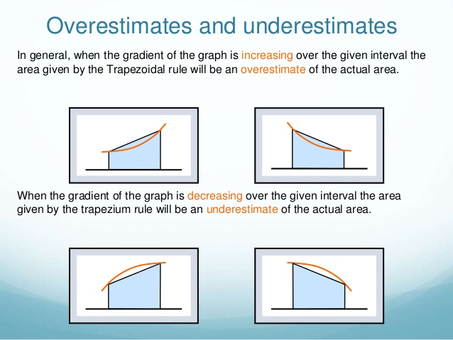

Q4: This is about geometry. It’s good to be aware of all the circle theorems for this and you’ll be using a lot of areas of triangles and Pythagorus. It can sometimes be useful to draw lines on diagrams (including given ones) such as in 2013 Q4. There’s also coordinate geometry which works similarly but with things like perpendicular lines have gradient which multiplies to -1. Similar triangles also appear here so it is worth being able to recognise them, when they exist it can help simplify problems a lot (2016 Q4). Symmetry helps a lot in these problems too.

Q5: These questions are a bit more random, they’re typically not on content which is on the A level spec so they feel like interview style problems to me - they want to see how you think. Common elements are usually sequences, recurrence relations and combinatorics. They sometimes give you rules to construct things too (2014 Q5) or recursive functions (2019 Q5) which leads nicely into recurrence relations.

To form recurrence relations, think about the problem combinatorially (the usual technique you’ll need in MAT is called committee selection) and break it down into cases - a good example is MAT 2014 Q5. This technique is very similar to double counting where you count the number of things in two different ways to show that the two expressions are equal, there are good examples here: <https://laurentlessard.com/bookproofs/double-counting-part-1/> and there’s a part two for some extra questions: <https://laurentlessard.com/bookproofs/double-counting-part-2/>

Recurrence relation trick e.g xn=3xn-1 + 4 solve by homo or by adding 2 and making it geometric.

This website has a few good examples of problems where you need to break it down like MAT Q5s such as the Tower of Hanoi and the Fibonacci rabbit thing: [Chapter8-counting-ad.key (iit.edu)](http://www.cs.iit.edu/~wan/cs330/Chapter8-counting-ad.pdf)

I recommend attempting the questions before reading the solution. Another one is ‘How many ways are there to fill a 2xn rectangle with 2x1 dominoes?’

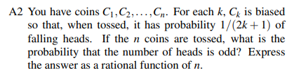

This is another good question to try of this style, Putnam 2001 A2. These questions might feel unfamiliar for a while but with enough practice they will become manageable.

Q6: I did only Q1-5 as I did it for Imperial maths so the advice for this may not be very good - I’ve never done any Q6/Q7 so this is based on what I thought as I flicked through them.

It looks like in old papers, this used to be just logic puzzles but in recent papers they’ve changed a fair amount. In logic puzzles, it’s very much about going through all of the different cases and ruling out what’s impossible to get to the conclusion (however improbable….) In recent years, they seem more random than even Q5 is, the aim likely being that the question exists to test you on your reasoning only rather than strength at a topic. In that case, doing well on Q6 is mostly about your problem solving skills which will improve as you do MAT & other hard problems (Olympiads, STEP etc)

Looking at the past 3 years, Q6 seems to often be about a procedure/algorithm, they introduce some concepts and want you to do things with specific simple cases and then it becomes more general as the question goes on. These smaller cases will help you get used to the more general process they want you to understand.

Q7: This is more consistent than Q6. They give you rules which define something and you need to apply these rules, like axioms. A good example is 2013 Q7 where it wants to construct words based on some rules. In this way, there’s overlap with other questions - Q5 and Q6. Q5 in particular with things like the Martian Classical Period and 2018 Q5 are really similar. Like Q6, you generally work with a few simpler cases and then build up to a more general/more complex cases. Just like those two questions, improving problem solving skills is all you can really do. For those not doing Computer science, doing Q6/7 might help with Q5 if you’re struggling a lot on it but probably not that much.

For both Q6/7, the STEP foundation module warm downs sometimes have logic style questions (especially like the old logic puzzle style Q6) such as Assignment 12s warm down. You can see what the warm down is in the description of the assignment - it's probably best to bother with only the ones which are relevant but if you have time/find it fun you can do all of them. The Oxford Computer Science department recommends this for Q6/Q7 http://www.bebras.uk/

Regarding old MAT papers (1996-2006), there’s not much point doing them as they’re generally too easy to be helpful - I remember worrying about not being able to do them as I discovered them a week before my exam and I felt like I’m suddenly a lot less prepared! The most useful thing in these are the question 5s as there’s not much like them in other things like STEP. Mt 1998, 2002, 2003, 2004, 2006 Q5 seem to be the most relevant ones.

For the multiple choice:

1.You can avoid the working out a lot of the time by substituting certain values to eliminate certain cases (2019 Q1B), especially for long general calculations like integrals or expansions (2014 Q1G). Another good thing to do when direct values aren’t easy is to consider extreme cases such as x=0 and when x-> +- infinity (2014 Q1D). This idea was also mentioned above in the part about graph sketching under interview advice.

This is really good for multiple choice about graphs - usually all options can be eliminated via substitutions and some properties of the graph like where its positive/negative etc. (2016 Q1E, 2015 Q1G, 2014 Q1B). Similar ideas work for comparing sizes of integrals, finding lower/upper bounds (2017 Q1J). Signs are important as well as:

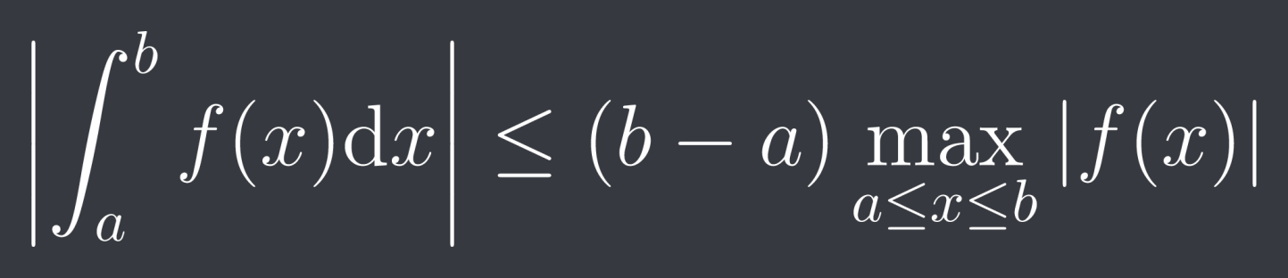

Also for integrals, be aware of the reflection (or King’s property): The idea behind this is very similar to the one in 2016 Q3 where the integral is the same because you’re integrating over two intervals where the integral takes the same values but this holds generally.

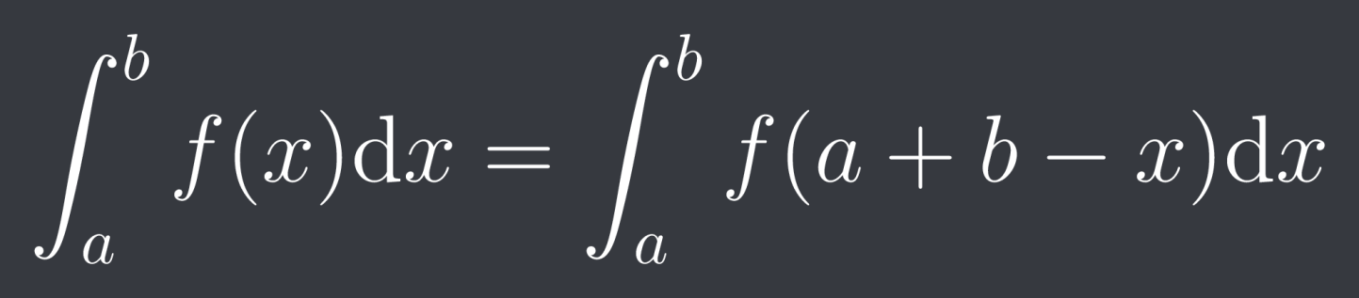

and that if you reverse the limits on integrals, the sign changes (2016 Q3)

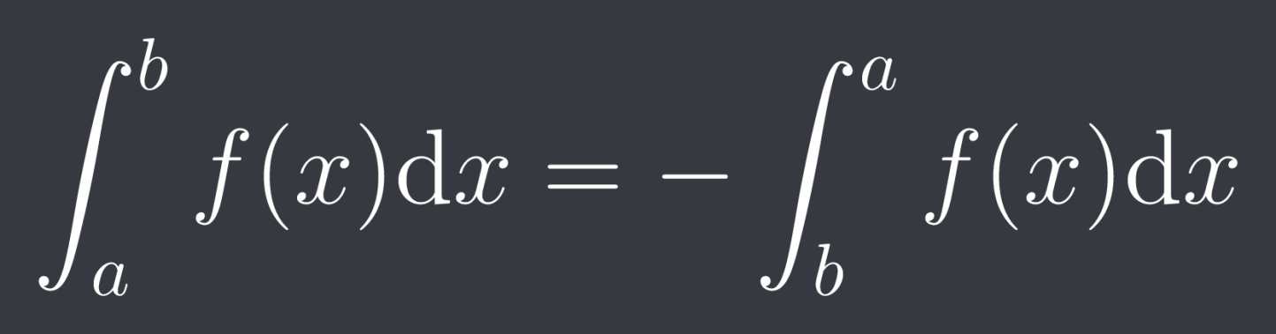

2. Graphs are also a good way to investigate integrals/areas when its hard to directly evaluate them (2015 1F).

3.For Trigonometry, remembering identities (like sin(pi/2-x)=cosx) and graphs help for numbers of solutions (2015 Q1E). Specific values applies here too.

4.For floor function integrals, you can either substitute values or you can draw the graph and consider it as the sum of the area of rectangles like in (2013 Q1J)

5. For questions about comparing the values of things involving logarithms, its much easier to deal with powers than logs so convert them (2015 Q1J). They generally ask which is the biggest so compare them to the one you think is biggest.

6. For Sequence questions in general, even not MCQ, if you’re struggling, it’s always good to test a few small values to see if you can find a pattern or anything else which is relevant (e.g 2017 Q1C, 2016 Q1G).

7. Sometimes questions appear about minimum values; these are sometimes just quadratics and then completing the square/solving it can be done which makes it a lot easier/quicker to deal with (2014 Q1E, 2016 Q1D). Circles are also another good place to complete the square.

8. A particularly relevant Graph sketching thing for MAT is that to determine the number of solutions of a cubic, its sufficient to consider the signs of the turning points; if they’re both the same sign then there is only 1 root and if not there are 3 roots (you might like to draw graphs of the cases to see why this is true).

A good resource if you run out of MAT stuff is DrFrost maths but I haven't ever used it, I've heard some people recommend it <https://www.drfrostmaths.com/resource.php?rid=177>

Tips & Tricks:

I did a stream on the STEP Discord server about this, here they are (I think some got cut off as I thought the full thing was 1 hour and 30 minutes but oh well)

[Vishal Mat talk 1.11.21 - (1 out 2).mp4 (dropbox.com)](https://www.dropbox.com/s/eu1m8ak0qkim88z/Vishal%20Mat%20talk%201.11.21%20-%20%281%20out%202%29.mp4?dl=0)

[Vishal Mat talk 1.11.21 - (2 out 2).mp4 (dropbox.com)](https://www.dropbox.com/s/j6a25kicakogc4g/Vishal%20Mat%20talk%201.11.21%20-%20%282%20out%202%29.mp4?dl=0)

The main ideas, tricks, tips and recurring themes are:

1. Comparisons of numbers are quite common (Q1J 2015, Q1 in 2008 etc.)

For these you generally should be dealing with square roots and logs. For square roots, square them so that they can become integers you can easily handle. For logs, they will generally be close to powers which you normally know / can easily work out e.g 2^4=16 which will let you bound.

1. Strictly increasing implies injective

Useful thing to be aware of.

STEP:

For STEP, a lot of the advice about past papers carries over from MAT. Don't worry about starting preparation late, most people start after they get their offer in January. For interview preparation I recommend doing STEP 1 with things like the foundation modules: https://maths.org/step/assignments. If you find the warm up etc too dry, what I did was skip straight to the question, if I could do it, I moved on, if not I would do the preparation etc. The warm downs are generally just fun things to think about, some of them can be fairly useful for the interview. I recommend doing these over the holidays of year 12. There are also modules for STEP 2 and 3, these aren't as developed as the STEP 1 ones and I think at this point it's better to just start doing past papers. The accompanying topic notes are pretty useful on these modules.

Solutions to STEP can be found in multiple places such as TSR (by searching something like Step 3 2001 solutions), the solutions by MEI: <https://mei.org.uk/step-aea-solutions>. There’s also mark schemes in the STEP folder from an FOI request and every paper from 2015 has the mark schemes available in the zip files on the website. It’s best to try questions for a while before resorting to solutions if you’re stuck - what I did is I tried for an hour and then left it for a day if I still couldn’t do it and come back to it - the break helped me come back with a fresh perspective. If you’re still tenacious to solve it yourself, instead of reading the full solution, you could read slightly past where you were stuck to get a hint and see if you can carry it on !

The main thing I recommend regarding papers is to do applied questions, pretty much everyone I know who did STEP wishes they did applied earlier, Statistics in particular as those questions are generally like pure but with in probability language (usually combinatorics or integration for discrete/continuous). Mechanics is harder to get used to at first but it will click over time, the topics I recommend starting with are collisions and projectiles and then moving onto circular motion and SHM. That’s because I think the main difficulty in mechanics is modelling the situation well and recognising what physical elements are important for what. This is things like the directions momentum is conserved in and for restitution, motion on inclined planes is just restricting its motion into one dimension, taking moments about places to cancel as many forces etc. These topics involve the least modelling and increase gradually, eventually you’ll get used to modelling more complex situations to do the other mechanics topics and questions. I used to recommend doing every paper as a timed mock to see how you're doing over time but now I believe it’s best to focus your initial preparation on getting good at a wide range of topics which is best done by focusing on a specific topic for a while. Once you can answer most questions in a good range of topics well, you can do timed papers to speed up.

Regarding the number of questions, always go for 6. It's much easier to get the first 5 marks of a question than the last 5 marks and sometimes the questions are weighed very nicely with the final difficult part only being worth 5 or so marks - this is common for graph sketches in particular where the first parts are some relatively easy results to help draw the graph so don't worry about partials much.

For picking questions, I recommend reading through the questions and rating them out of 10 for how good you think they are. That means you don't have to keep rereading during the exam and once you do a lot of papers, you get a good idea of which topics are good for you so this generally takes 2 or 3 minutes by the end.

My final advice for both is during the exam, make sure you stay calm even when you are struggling to get something out because these exams challenge you to think on a timer which is a scary experience. This is part of why mocks are good to get you used to that feeling. If you panic, you may start making mistakes so try to stay focused despite things going badly and you'll do better. Good luck for your exams!

Also refer to the document on my website about things that I commonly made mistakes on for STEP - it should also be helpful for MAT.

Some things which I often got wrong in STEP questions:

* Equations like y^2=-x^2-2x are circles, parabolas on the other hand are always of the form y^2 = f(x) where f is a degree 1 polynomial in x.
* y=sqrt(x) has a gradient which approaches infinity as x goes to 0. This is worth keeping in mind for y^2 = f(x) graphs where relevant!
* t**r**=s**b** for scalars t,s and vectors **r** and **b** means t=s unless the vectors are parallel (this is about linear independence). This lets you ‘compare coefficients’ for vectors like you can for polynomials which is useful.
* Magnitude of vector **v** is sqrt(**v.v**), this form is really useful instead of working with components of vectors which usually not a good idea!
* To find the maximum term of a sequence an, you can consider either the ratios of consecutive terms until you get one such that an+1/an < 1 and an/an-1 > 1 so an is the maximum. Or you can check differences for an-an-1 > 0 and and an+1 - an < 0

Personal statement/extracurriculars:

First, for Maths at universities like Cambridge, Warwick and Oxford (most high ranking ones but not all), they won't really read / care much about your personal statement. For example, Warwick claims they briefly look at it for a few minutes and never look at it again and I've heard Trinity have said that they read it just because they have to. This is because they have better means to measure the suitability of a candidate for their course such as interviews and admissions tests.

What you should take away from this isn’t that you don’t need to write a good personal statement but that you don't need to worry about doing extremely specific extra curriculars or very minute details. Make sure the statement is good for other universities. James Munro, the admissions director at Oxford put it best when he said 'if you have an hour to either improve your personal statement or do some maths, you should do some maths'.

Also, they're generally not interested at all in anything in your personal statement which isn't about maths but it is good to have a line or two on this for the sake of other universities. In the interview, they're generally unlikely to ask you about anything on your personal statement but it's worth being aware of what you wrote about on it in case they ask you on something related to it. If you claim you know a lot of university maths, you should know it! You should also know a little bit around it too. To take an example from university maths, if you say you know Cauchy’s integral theorems then you should know Liouville’s theorem, an important (but quite quick) deduction from Cauchy’s integral formula.

However, this doesn't mean that doing extracurricular maths is a bad thing, in fact it's probably the best thing you can be doing at this stage - it's just that you shouldn't do things just for the personal statement and instead explore the maths you enjoy the most and want to learn about the most. That way, you'll learn a lot more and end up organically having a lot of things to write on your personal statement later on which will make writing it a lot easier. These are now some possible suggestions of things you can do which you might enjoy:

1. British Mathematical Olympiad problems. These are fun problems you can do which focus on problem solving ability over specific knowledge. They are difficult but the first few questions tend to be accessible and you'll find you improve fairly quickly. Past papers are here: https://bmos.ukmt.org.uk/home/bmo.shtml and you might find books like 'A Mathematical Olympiad Primer' by Geoff Smith or a more advanced book, 'Problem Solving Tactics' by Angelo Di Pasquale et al. useful for Olympiad style problems. You might also enjoy doing British Physics and British Informatics Olympiad problems if you do Physics or Computer Science as they involve a lot of problem solving in a similar vein to maths. There's quite a lot of websites for programming problems online such as Project Euler or competitions on websites like Kattis or Codeforces.

2. STEP Foundation modules. These are more directly relevant to what you'll need to be studying for the STEP exams in year 13 once you get your offer. They're a really good way to ease into doing STEP questions and can introduce you to new maths you might enjoy. https://maths.org/step/assignments

Somewhat related is Stephen Siklos' booklet for STEP which is similar to the foundation modules: https://stepmaths.co.uk/free-download-stephen-siklos-advanced-problems-core-mathematics-step-preparation/

In a similar vein, you can start looking at Oxford's MAT papers which are a bit tamer than STEP as they're taken earlier in year 13 https://www.maths.ox.ac.uk/study-here/undergraduate-study/maths-admissions-test . Oxford is also running a bunch of maths stuff on their youtube channel weekly with James Munro where students discuss some aspect of maths they enjoy: https://www.youtube.com/OxfordMathematicsPlus

3. Youtube channels such as 3blue1brown, Michael Penn and blackpenredpen often discuss interesting math - the latter two focus more on solving problems from a variety of sources (Putnam, Olympiad etc.) which you can also look into.

4. Reading a book about maths. This is something a lot of people put on their personal statements. I feel like it's useful but it isn't necessary so don't worry about forcing mentioning you've read a book. There are many reading lists by universities online you can look through, here's one by Cambridge: https://www.maths.cam.ac.uk/undergrad/admissions/files/reading-list.pdf

I haven't read most of the books on the list. I recommend anything from the 'A very short introduction to' series as they're small enough to fit in your pocket and read while walking around - I read the one on Numbers while walking to school.

5. Interview preparation. It might be a bit early to be doing this stuff but there's a lot of fun problem solving in interview preparation resources such as the TBO booklet: https://www.drfrostmaths.com/resource.php?rid=261

6. Online courses. You can find a lot of online math courses on websites like Coursera. One I really enjoyed was this one by Professor Chasnov: https://www.coursera.org/learn/fibonacci . You can find a lot of topics which are university level and stuff which isn't taught at A level. You can also look through university courses with notes online, Cambridge has notes for basically all its courses: https://dec41.user.srcf.net/notes/ with other sources of notes online too. I don't recommend learning university maths yet though because you have three years to do that already!

Writing the personal statement:

First I’ll note that this is what I did for my personal statement so this is just advice on what you could do to help write the personal statement.

I think it’s much better to write about specific things you learnt about or problems you did as opposed to generalised comments. The way I found easiest to write a personal statement was to talk about what I’d gained from doing a certain thing and by being specific and going into a fair amount of detail I could both discuss specific maths I’m interested in along with what I’ve learnt about it by doing it. For example ‘Putnam problems introduced me to more advanced problem solving and encouraged me to bring together different areas of mathematics I’d learnt together such as matrices and number theory in problem B4 in the 1994 Putnam paper. Because this combination of subjects was unfamiliar, I worked toward a solution by trying to find as much information as possible and synthesising it together. It also introduced me to a new perspective on Pells equation which I studied further in a paper by Seung Hyun Yang.’ -

and I could continue talking about Pells equation for a little while.

This example also highlights the way I structured my personal statement; I tried to make each topic flow from another both to give a sense that my mathematical studies aren’t in isolation - interest in one thing often led to interest in another. It also makes it easier to read and less like a list of things, instead more like a mathematical journey which is what the personal statement is about - your journey through mathematics. Another nice effect of it is that it shortens the amount of characters by linking them instead of listing them separately.

You could also discuss links between different things you discovered as you study more math. That may be across different fields of maths (i.e analysis and number theory to show the sum of reciprocals of primes diverges - look up the Euler product of the Riemann zeta function if you’re interested) or even across multiple subjects. One thing I liked was discussing how programming helped me solve problems by verifying things numerically or how I could use mathematical ideas to make my algorithms more efficient i.e using symmetry to avoid having to repeatedly calculate the same things. Another good subject to link to is Physics where you could solve a physical problem and encounter some new mathematics you haven’t come across yet. For me one which was interesting was when analysing pendulums, something called an elliptic integral appeared.

I applied this idea of writing about what I gained from a certain activity to everything in my personal statement and only focused on what I learned or found useful from it - I don’t think it’s worth worrying about where you learnt it from. It may be from a book, youtube video or article online but Oxford and Cambridge won’t worry about where it’s from but what you gained from it so don’t worry about if you can’t find a book or if they’ll look down on mentioning a youtube video. With something bigger like a book though you can probably zoom in on several specific things you learned from it making it more versatile.

About introductions and conclusions, you should probably write what you feel like works best. I don’t really like things like quotes and going on about why you love maths, I just mentioned I’m interested and then started discussing what I’d learnt in my studies to show it. I did pretty similar for my introduction, I just concluded with something about how I enjoy maths and that’s why I want to do a maths degree at university - I don’t think you need to end with a ‘bang’ or anything to make it memorable - I preferred just saying what I needed to. Some advice I got when writing mine was to link back to why I want to study a maths degree throughout like ‘this gave me this skill which is useful in math degrees’, generally at the end of a paragraph which you might like doing.

Some personal statement advice from Cambridge: [How to write a great personal statement (cam.ac.uk)](https://www.undergraduate.study.cam.ac.uk/writing-a-great-personal-statement)